SEAWATER PROPERTIES
NAME:
SUBJECT: GEOL1551
9TH SEPT 2020

Objectives
To familiarize with methods of collecting seawater properties data (e.g., salinity, temperature, pH) etc.
To learn how the data may be displayed and interpreted to understand oceanographic processes.
Part 1
- Figure 4 below represents a group of sea surface temperatures taken as part of a program known as Organization of Persistent Upwelling Structures (OPUS). The data are from a region near Point Conception and Point Arguello, California. Surface temperatures were recorded at a depth of 2 meters by lowering an instrument from a Scripps Institution of Oceanography ship.
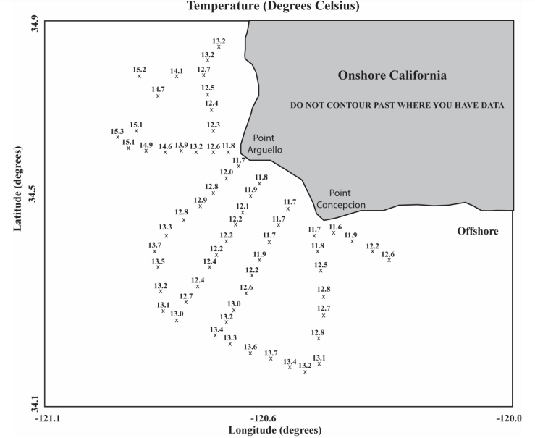
  - Contour the surface temperatures at a 0.5 Celsius-degree contour interval. It is suggested that you contour whole degrees to start, then fill in half-degree intervals by interpolation. You should have isotherm contours from 12ºC-15ºC. An isotherm is a line connecting points of equal temperature.

  - Is upwelling occurring here? If so, which type? Hint: The dominant wind direction along the coast of California is from north to south.

Yes there is an occurrence of upwelling because they tend to push cold water from below towards the coast the warm water are driven far away from the coast. Hence the kind of upwelling experienced here is coastal upwelling.
- Refer to the information given in this lab, your textbook and Figures 1 & 2 to answer the following questions:
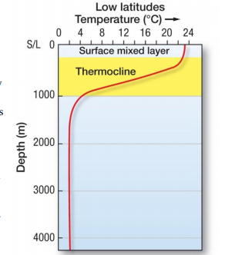Fig. 1. Illustration of the thermocline at low latitudes (near the equator) in the world’s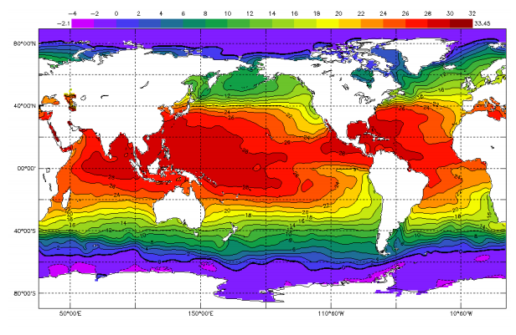Fig. 2. Map of monthly mean August sea surface temperatures

  - Where is water of the greatest density formed? Why?
Water of the greatest density is formed at high latitudes because water at this point sinks and fills all the deep ocean water basins, the deep and water at the boom of is extremely cold and thus greater density. The colder the water, the denser it is.
  - Draw a depth vs. temperature curve for the Arctic (left) and one for the equatorial region (right). In the middle, explain the difference between them. In which of these regions will surface and deep water vertically mix?
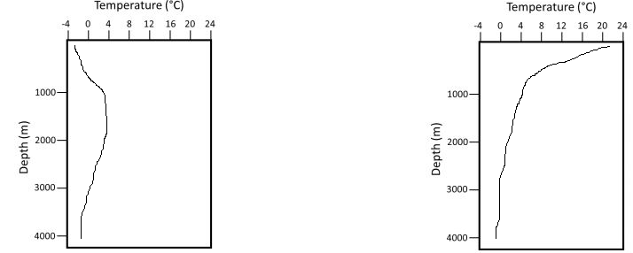
Arctic Equatorial
Equatorial water bodies are much warmer than water bodies in the Arctic regions.
Surface water in artic regions are much colder than deep waters while surface water in equatorial are much warmer than the deep waters.
Surface and deep water vertically mix at zones of divergence or upwelling zones more so near the equator.

  - Why is water so much cooler along the coast of North America than at equivalent latitudes on the opposite side of the Pacific Ocean?
The movement of Alaskan and northern ocean currents towards the South carries with them warm polar water, leaving cold water along the coast of North America.

Salinity
- Give the concentration of seawater with a salinity of 3.69 percent (%) in the following units:

  - 36.9 Parts per thousand (‰)
  - 36900 Parts per million
  - 36.9g_ Grams (salt) per kilogram (water)

- What is the salinity of seawater with a chlorinity of 20.3‰? Show work.
Salinity (‰) = 1.80655 X chlorinity (‰)
Salinity (‰) = 20.3 * 1.80655 = 36.673 (‰)
=36.673 (‰)
- Using Figure 5 answer these questions:
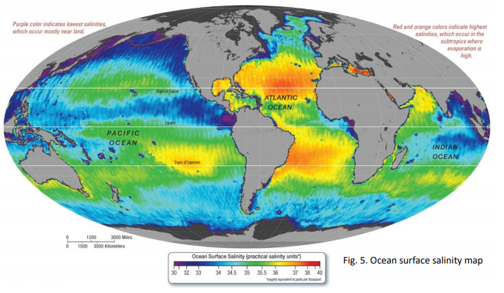
  - Give a latitude range for where salinity values are high. At approximately 30° to 40° N and 30° to 40° S. Give a latitude range for where salinity values are low At approximately 50° to 70° N and 50° to 70° S.
  - Which of the two oceans (Atlantic or Pacific) is saltier? By what amount (approximately)?
Atlantic Ocean is more salty than pacific. Atlantic Ocean has salinity of approximately 36 (‰) while pacific has salinity of approximately 35(‰).

  - Why do you think that ocean would be saltier, given what you know about drivers of salinity from the lab text?
Salinity of an ocean is as a result of several natural influences and processes for instance, erosion of bedrocks, rocks on lands, nutrients being washed away by rivers and rain water which are eventually deposited into the ocean. Combination of all this process i.e. erosion of rocks, minerals being washed by rivers and rainfalls and then being deposited into the ocean makes oceans become saline.

Part 2:
Use interactive data found at the specific URLs below to address the associated questions:
Visit: http://explorations.visualocean.net/chemistry/activity1.php?level=application
Look at the background information to answer the following questions.
- What is a mooring in this context?
A permanent structure where water vessels are secured.
- What is a CTD? What data does it acquire, and what data can be calculated from it?
CTD stands for Conductivity, Temperature and Depth hence a package of instruments used to measure conductivity, Temperature and Depth of oceans/seas. CTD acquires the temperature and salinity (through conductivity) of water which in turn is used to determine the density and pressure of water and from there the depth of water is determined.
Choose “Coastal Atlantic vs. Coastal Pacific” dataset. Look at the data graph to answer the following questions.
- Where are these data from? Be specific.
The data is from northern hemisphere off of Massachusetts and Oregon coasts

- What is the range of variation of salinity through the year for the Pacific versus the Atlantic mooring? Which is higher? Does this match your observation of the static map averages in Part 1 Question 5b?
Salinity is higher at Atlantic than at Pacific. Salinity ranges from 32 to 35.5 in Atlantic and then ranges from 26.5 to 33.5 in Pacific. The information matches the observation of the static map averages in Part 1 Question 5b where Atlantic Ocean is more salty than pacific. Atlantic Ocean has salinity of approximately 36 (‰) while pacific has salinity of approximately 35(‰).
Visit: https://datalab.marine.rutgers.edu/explorations/chemistry/activity2.php?level=exploration
Explore toggling on the different parameters that may affect ocean salinity (Air Temperature, Sea Surface Temperature, and Rain Rate) while comparing to salinity measured off the Oregon coast in the Pacific Ocean. Notice that the left Y-axis shows salinity values, and the right Y-axis shows your chosen second parameter. You can change the time period from the full year to only certain months by using the bar below the graph.
- Toggle on rain rate – What effect does a high rain rate have on salinity measurements? What about a low rain rate?

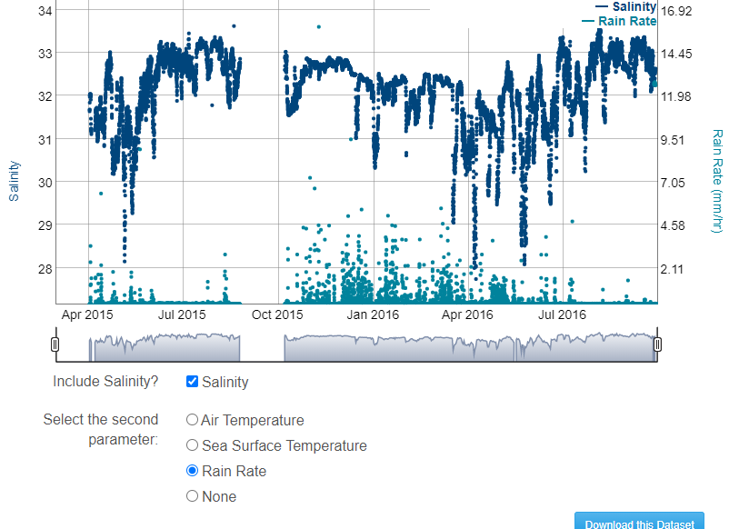

High rain rate reduces salinity since it dilutes salt concentration of the ocean. Low rain rate on the other hand results in an increase in the rate of salinity since there will be a reduction in the rate of precipitation.
- How do your detailed observations of these paired datasets support (or not) your answer to Part 1 Question 5a? Question 5c?
Salinity is lower in equatorial and Polar Regions due to high rate of precipitation. However, salinity is high in subtropical regional and mid-latitudes due to high rate of evaporation that tends to exceed precipitation.

Assessing the pH of seawater Visit: http://explorations.visualocean.net/chemistry/activity3.php?level=exploration
Using Background Information
- These data were acquired from which mooring site and what water depths?
Data was obtained from the Oregon Offshore Profile mooring site from the surface to 200 m water depths.
- What does pH actually measure within the ocean water?
It measures the acidity and basicity of water by measuring the amount of free hydrogen and hydroxyl ions in water.
Data Graph
- As you descend through the water column does it become more acidic, or more basic?
It becomes more acidic
Visit: https://datalab.marine.rutgers.edu/explorations/chemistry/activity4.php?level=exploration
Using Background Information
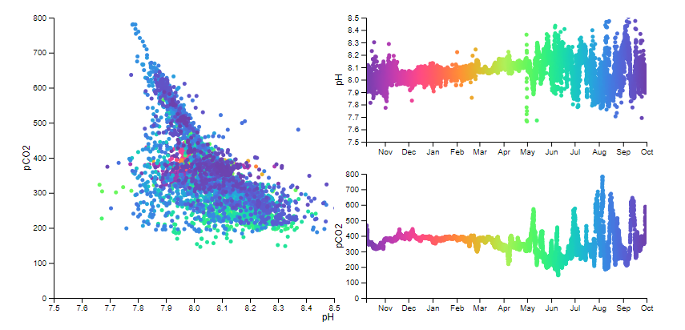
- Where were these data acquired? What mooring site and what water depths?
The data was acquired from North Pacific Ocean, Oregon Offshore Profile mooring site from the surface to 200 m water depths.
- What data are we looking at in each of these graphs? What is the time frame of this dataset?
The data we are looking at is that of pH and pCO₂ levels in a span of 1 year (November 2015- October 2016)
Using the data graph – click and drag a box in the upper right graph to select different time frames of interest.
- Select a box size of ~1 month in length and scroll it through time to observe how the scatterplot changes through over the course of the year. During which months (or seasons) is there little “scatter” in the data? March to April (When is the data on the left restricted to a small range of pH and pCO2 values?) During which months is there wide variability in the data? June, July, August, September and October.

- Look at the data from August to September. Describe the relationship you see between pH and pCO2 that month. In other words, when pH levels are high in August/September, are the pCO2 readings in the water high or low?
When PH levels are high in August, pCO2 levels are also high and in the month of September, where PH levels are still high, pCO2 levels appear to be dropping.
- Why do you think there is more variability in this data during certain parts of the year, and less variability in others? (Consider what contributes CO2 to the water column!)
CO2 levels varies in all seasons of the year. Plants tend to take more of CO2 during warm seasons since they are growing the most in this seasons and as a result the levels of CO2 drops during warm seasons and this results in an increase in PH levels, making water bodies less acidic for instance in the months of May to September. During cold seasons, there is more CO2 in the atmosphere as plants tend to have reduced intake of CO2 and this results in a drop of PH in water bodies which make water bodies more acidic for instance in the months of November to March.

